Referral Request Form

To: Amit Patel, MD Bhakti Paul, MD From: ______________________________
______________________________
c/o NRE Referral Coordinator ______________________________

Date: ___________________ Total # Pages Including Cover: __________

Fax Number: 919-847-5699 Sender’s FAX Number: ________________
Phone Number: 919-844-6218 Sender’s PHONE Number: _____________

PLEASE PROVIDE THE FOLLOWING INFORMATION:
Demographic Sheet Insurance Office Notes Lab Results Imaging

Patient Name: _________________________________ DOB: ________________
Patient Mailing Address: ___________________________ City__________ State____ Zip Code _______
Patient Main Contact #: ____________________ Patient Mobile #: __________________

Routine Urgent (24-48 hours)
Location Preferred (circle one): North Raleigh or Wake Forest

THYROID / NODULES DIABETES CONSULT OSTEOPORSIS CALCIUM DISORDER

PITUITARY HYPOGONADISM ADRENALS OTHER:

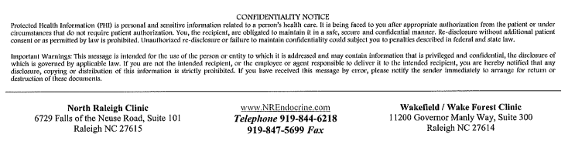
NOTES/REASON FOR CONSULT:

